**The availability of vegetative mesohabitats determines bird behavior in desert habitats**

Not bad - availability a bit odd as a term - other options or synonyms?

Owen, M.B., Lortie, C.J.

Abstract

Positive interactions, such as mutualism, are key interactions many species use in order to survive harsh environments like deserts. In animals, mutualistic interactions with plants include pollination and seed dispersal. Because plants provide resources like food and shelter to birds, these plants are often the site of these mutualistic behaviors. By providing resources to interspecifics, foundational plants engaging in mutualistic interactions promote their own fitness as well as the interacting birds. We hypothesized that there are associations between birds and foundation plant species such as shrubs and cacti, and these relationships change with phenology. We found that bird community structure was significantly more diverse in spring at all mesohabitats sampled (shrub, cacti, and open?). , that site-wide behaviors?// what is this? are influenced by the birds found in a system, and that behaviors were influenced by mesohabitat>>??? Confusing - see below - state hypothesis and then work through how it was supported or not. These findings suggest that availability of foundational and keystone plants species is important for the expression of bird behavior good - so that is likely in the hypothesis in some form. The expression of behaviors is confusing - see my Functional Ecology review paper - do you mean the reciprocal function that the animal provides to the cacti or foundation species or something like that? I think simpler language good here - ironic I know given the Facets paper and my writing - sorry. Easier to edit, harder to do.

Positive interactions including mutualism are important in relatively high-stress ecosystems such as deserts. Plants and animals typically associate through pollination and seed dispersal. Phenology or the timing of reproduction in plants is thus a critical factor in maintaining positive interactions with animals such as birds. We tested the hypothesis here that there are associations between birds and cacti and these relationships change with cacti flowering and fruiting. Is that it? We used…. Two sentences of methods then state key findings as you did and end with implications. good.

1. Introduction

Desert ecosystems are generally stressful. Numerous factors including ultraviolet radiation, heat, water scarcity, wind, and other abiotic and biotic ecological factors contribute to this harshness relevant to plants and to animals (Maestre, Valladares, and Reynolds 2005; Bonanomi, Incerti, and Mazzoleni 2011). Positive interactions between plants and animals are thus relatively common in high-stress systems (Lortie and Callaway 2006). Facilitation is broadly defined as the association of a benefactor plant species with protegee plants or animals by increasing germination, growth, and recruitment of protegee species (Franco and Nobel 1989). In arid ecosystems, facilitation by foundation species can provide resources like water, shade, and pollinators (Flores-Torres and Galindo-Escamilla 2017; Miranda-Jácome, Montaña, and Fornoni 2013; Mitchell et al. 2009), or protection from trauma by herbivory, trampling, freezing temperatures, predation, and wind (Gómez-Aparicio et al. 2008; Parker 1989; Tewksbury and Lloyd 2001; Nobel 1980). Benefactor species which facilitate many interspecifics in an ecosystem are known as foundational species (Angelini et al. 2011; Almeida and Mikich 2018) and tend to dominate an ecosystem. Shrub species have been documented as the most common foundational species globally, though trees and cacti are two other common vegetative benefactors (Filazzola and Lortie 2014). These large, sturdy plants are largely responsible for habitat infrastructure of wildlife throughout an ecosystem (Callaway 1997; Gelmi-Candusso, Heymann, and Heer 2017). While most studies have focused on plant-plant facilitation (Callaway 200AD), there is also evidence for the importance of plant-animal interactions in stressful environments (Lortie, Filazzola, and Sotomayor 2016; Bertness et al. 1999; Arsenault and Owen-Smith 2002). However, a more comprehensive understanding of what resources or services animals contribute to the interaction may illuminate pathways of habitat creation that, so far, is less understood.

Compared to facilitation which can often be a +/0 interaction, mutualism is a +/+ interaction. Mutualism is a category of positive interaction wherein the participating parties both benefit from an interaction, usually in the form of resource acquisition that increases the survival or fitness of the parties (Barker et al. 2017; Bronstein 2009, 2001). Pollination and seed dispersal are two common forms of mutualism that directly create and maintain habitat in most ecosystems, both of which are performed by birds found in desert ecosystems. Birds are unique in their mutualistic interactions with plants in that they can travel far distances with seeds in their guts (Spiegel and Nathan 2007), deposit large pollen loads (Ramsey 1988), scarify seeds in their gut, thereby promoting germination rates (Traveset and Verdú 2002), and participate in general and specialized interactions which produce habitat infrastructure (Devictor, Julliard, and Jiguet 2008). Despite this, birds are understudied as important actors in arid ecosystems compared to insects like bees and beetles. Examining the relationship from the bird and the cactus perspective in concert will lead to a better understanding of how ecosystems maintain their own habitat, and how managers can employ these natural systems for conservation purposes.

This concert of interacting species is, however, dependent on temporal and geographic limitations. Phenology in desert ecosystems can vary widely due to the extreme plasticity of temperature and precipitation (Henen et al. 1998) including cacti & shrubs (Schwartz 2003; Beatley 1974; Jordan and Nobel 1983; Nobel and Hartsock 1981) and bird migration and breeding seasons (Scott Sillett and Holmes 2002; Runge and Tulloch 2017; Fahse, Dean, and Wissel 1998). This suggests that for animals that rely on or associate with cacti for resources, timing is critical (Buler, Moore, and Woltmann 2007). Phenological mismatch has been studied in deserts (Kellermann and van Ripper III 2015) and is important to explore interactions through time and space at different reproductive stages of the foundation plant species or pollinating/seed dispersing birds in a system, as these limitations determine the capability of plant/bird reproduction to occur, and therefore, habitat creation. However, we must first determine the potentiality for these interactions to even occur before we can determine the implications of phenological mismatches.

In this study, we examined the hypothesis that there are associations between birds and foundation plant species such as shrubs and cacti, and these relationships change with phenology. Our research questions are: 1) How does desert bird community change between migratory/flowering seasons (hereafter referred to as spring) and breeding/fruiting seasons (hereafter referred to as summer)? 2) How do birds associate with available plant mesohabitats or exhibit different behaviors in different seasons? And 3) are mesohabitats fostering certain behaviors among birds? We predict that 1) bird community structure will be different in the spring season than in the summer season, 2) observed mesohabitats and behaviors will be defined by the birds’ functional and taxonomic diversity, and 3) bird behavior changes as their occupied mesohabitat changes.

1. Introduction

Desert ecosystems are generally stressful. Numerous factors including ultraviolet radiation, heat, water scarcity, wind, and other abiotic and biotic ecological factors contribute to this harshness relevant to plants and to animals (Maestre, Valladares, and Reynolds 2005; Bonanomi, Incerti, and Mazzoleni 2011). Positive interactions between plants and animals are thus relatively common in high-stress systems (Lortie and Callaway 2006). Facilitation is broadly defined as the association of a benefactor plant species with protegee plants or animals by increasing germination, growth, and recruitment of protegee species (Franco and Nobel 1989). In arid ecosystems, facilitation by foundation species can provide resources like water, shade, and pollinators (Flores-Torres and Galindo-Escamilla 2017; Miranda-Jácome, Montaña, and Fornoni 2013; Mitchell et al. 2009), or protection from trauma by herbivory, trampling, freezing temperatures, predation, and wind (Gómez-Aparicio et al. 2008; Parker 1989; Tewksbury and Lloyd 2001; Nobel 1980). Benefactor species which facilitate many interspecifics in an ecosystem are known as foundational species (Angelini et al. 2011; Almeida and Mikich 2018) and tend to dominate an ecosystem. Shrub species have been documented as the most common foundational species globally, though trees and cacti are two other common vegetative benefactors (Filazzola and Lortie 2014). These large, sturdy plants are largely responsible for habitat infrastructure of wildlife throughout an ecosystem (Callaway 1997; Gelmi-Candusso, Heymann, and Heer 2017). While most studies have focused on plant-plant facilitation (Callaway 2007), there is also evidence for the importance of plant-animal interactions in stressful environments (CITE Lortie et al Functional Ecology review; Bertness et al. 1999; Arsenault and Owen-Smith 2002). However, a more comprehensive understanding of what resources or services animals contribute to the interaction may illuminate pathways of habitat creation that, so far, is less understood.

Compared to facilitation which can often be a +/0 interaction, mutualism is a +/+ interaction. Mutualism is a category of positive interaction wherein the participating parties both benefit from an interaction, usually in the form of resource acquisition that increases the survival or fitness of the parties (Barker et al. 2017; Bronstein 2009, 2001). Pollination and seed dispersal are two common forms of mutualism that directly create and maintain habitat in most ecosystems, both of which are performed by birds found in desert ecosystems. Birds are unique in their mutualistic interactions with plants in that they can travel far distances with pollen loads or seeds in their guts (CITE), carry lots pollen on their bodies (CITE), scarify seeds in their gut, thereby promoting germination rates (CITE), and participate in general and specialized interactions which produce habitat infrastructure (CITE). Despite this, birds are understudied as important actors in arid ecosystems compared to insects like bees and beetles. Examining the relationship from the bird and the cactus perspective in concert will lead to a better understanding of how ecosystems maintain their own habitat, and how managers can employ these natural systems for conservation purposes.

This concert of interacting species is, however, dependent on temporal and geographic limitations. Phenology in desert ecosystems can vary widely due to the extreme plasticity of temperature and precipitation (CITE) including cacti & shrubs (Schwartz 2003; CITE) and bird migration and breeding seasons (Scott Sillett and Holmes 2002; Runge and Tulloch 2017; Fahse, Dean, and Wissel 1998). (Buler, Moore, and Woltmann 2007) deserts (CITE) and space t or pollinating/seed dispersing birds , as these limitations determine the capability of plant/bird reproduction to occur, and therefore, habitat creation. However, we must first determine the potential for these interactions to even occur before we can determine the implications of phenological mismatches.

In this study, we examined the hypothesis that there are associations between birds and foundation plant species such as shrubs and cacti, and these relationships change with phenology. Our research questions are: 1) How does desert bird community change between migratory/flowering seasons (hereafter referred to as spring) and breeding/fruiting seasons (hereafter referred to as summer)? 2) How do birds associate with available plant mesohabitats or exhibit different behaviors in different seasons? And 3) are mesohabitats fostering certain behaviors among birds? We predict that 1) bird community structure will be different in the spring season than in the summer season, 2) observed mesohabitats and behaviors will be defined by the birds’ functional and taxonomic diversity, and 3) bird behavior changes as their occupied mesohabitat changes.

Or do you want to do an even broader one about mesohabitat?

Or do a clear zoomed in one - Are we directly testing for mutualism between birds and cacti? If so, state that.

Predictions

1. Diversity of birds associated with cacti is greater than…
2. Phenology of cacti shifts the abundance and assemblages of birds associated with this foundation species.
3. NOW for 3 and 4 switch to the animal side right - like the new flow for intro and make two predictions about what the birds seem to be doing… and the functional classificaiton too as measure of function so for 3 - The functional diversity of the bird species associated with cacti relative to other microhabitats (ie I would switch all to micro not meso to match the facilitation literature) locally supports key ecological functions such as pollination and seed dispersal?
4. The observed behavior of birds associated with cacti suggests reciprocal benefits??? OR if you want to switch to more zoomed mutualism hypothesis - the observed behaviour of birds associated with cacti relates to higher net estimated seed production of these cacti… or if you want to switch to microhabitat functional mapping idea - the observed behaviours of birds in different microhabitats provides key evidence for reciprocal benefits to the plants? SAME Idas for prediction 3 - depends on the scale of your hypothesis - ie think about the bee literature for 3 ie if more pollinators visit a plant, we predict higher relative seed set - EXACT same idea here - More visits to cacti by birds and higher diversity of bird species visiting cacti, should in theory lead us to predict that these cacti ‘do better’ if there is at least bird-cacti facilitation or perhaps mutualism if the birds do better too - which I assume we do not measure.

GOOD?

NO - just finished paper - I do not think we measure mutualism at all do we?

Confused - unless these bird observation data or coupled to some measure of cacti doing better - then I think we can mention mutualism but that is not the whole point of paper…

1. Methods

2.1 Study Site

The research was done at the Sweeney Granite Mountains Desert Research Center (34°48′20″N 115°39′50″W) in the Mojave Desert. The 3,600 hectares elevation ranges from 1,128 to 2,071 m, and is not accessible to visitors and thus any disturbance. Rainfall varies significantly throughout the year with a mean 22 cm per year (citation), and no typically no precipitation in the summer months. The long-term July minimum and maximum is 20°C and 33°C respectively (Citation). The site is dominated by perennial woody and succulent shrubs such as Cylindropuntia acanthocarpa, Yucca mohavensis, Larrea tridentata, Ambrosia salsola, Pinus monophylla, and numerous other shrub species (cite species list from reserve). There have been 156 birds, 42 mammals, 2 amphibians, and 504 species of vascular plants documented at the reserve (citation).

2.2 Study species

While the Mojave boasts an array of diverse plants, a handful of foundational plant species dominate the landscape. *Cylindropuntia acanthocarpa,* or Buckhorn Cholla, is a shrub-like cactus with an irregular branching pattern. *Larrea tridentata*, or Creosote Bush, is a large, long-lived deciduous shrub that is well documented as a benefactor species for plants and animals. *Yucca schideigera*, or Mojave Yucca, is a flowering plant native to the region with several specialist and generalist relationships with fauna of the region (citation). While there are many other plant species found in the study site, these three are the most abundant of plant species and accounted for most interactions documented in this study.

The avian community of the Mojave Desert includes typical species of the American Southwest, but is also home to desert obligate species which rely on plant species only found in wild desert areas (e.g. the Cactus Wren, Campylorhynchus brunneicapillus). There are currently over 159 bird species on the Sweeney Granite Mountains Desert Research Center (Gurin, La Doux, and Coe 2012), and a complete list of all known avian species to the field site is available via the site’s website. The most common bird documented over both seasons was *Amphispiza bilineata*, or the Black-throated Sparrow. An insectivore, herbivore, and granivore, this year long resident of Southwestern deserts (citation trophic guilds) was seen or heard at every sampling replication.

2.3 Field observations

We used a 500-meter line transect over two-hour period block to sample the bird community. Transects were deployed between 7-10am or 5-8pm depending on daily temperatures, which were associated with peak bird activity. Two individual line transects were used and spaced 80 meters apart. The starting coordinates for transect 1 and 2 were (34.78299, -115.662) and (34.78303, -115.663) respectively. A single observer familiar with the local bird species recorded all visual or auditory bird cues and identified each observation to species. Some female/juvenile hummingbirds were identified only to family due to the visual similarity between species. In each instance, microhabitat was also recorded as list the categories here.. However, we only included visual observations of birds in microhabitat and behavioral analyses. Flyovers (defined as birds flying roughly 25 feet above the highest vegetation at site that did not land within sight) were not included as an observation. In addition to species, we also recorded behavior (as designated by an ethogram), mesohabitat, geographic coordinates, the time of the sighting/hearing, and an estimate of the distance from the transect(<25 meters, 25-50 meters, or >50 meters). We also took photographs of birds using a Nikon D5300 camera equipped with a Sigma 150-600mm lens which served as identification aids and behavioral/mesohabitat records.

2.4 Statistical Analyses

Behavior and mesohabitat functioned as dependent variables for each observation of a bird. Behavioral observations were then categorized into broader behaviors (active movement, cleaning, feeding, inactive, and territorial/mating). Mesohabitat level observations were distilled into two levels (vegetative or non-vegetative) and three levels (cactus, shrub, or other). Trophic guild and migratory class were the metrics we used to define functional diversity. We categorized all observed species into trophic guilds using “Foraging Guilds of North America” (De Graaf, Tilghman, and Anderson 1985) and into migratory classes using *Common Birds of the Sweeney Granite Mountains Desert Research Center* (Gurin, La Doux, and Coe 2012). Taxonomic diversity was originally recorded to species level, and then grouped into broader taxonomic designations (family and order).Using each line transect walk as a level of replication, we calculated species abundance (A), richness (S), turnover (T), and evenness (J) using the R Vegan Package (Oksanen et al. 2019). Additionally, we calculated Simpson’s Diversity Index (D) and Shannon’s Diversity Index (H) to encourage transparency on the influence of evenness or richness respectively. Using these different metrics for community structure, we created linear regression models to determine differences in community structure in spring and summer, excluding species richness. We used a general loglinear model (due to the non-normal, poisson distribution of species richness through both seasons) (citation). We included each walk of a transect in the models as a random effect. To assess the species variance impact on community structure, we did a principal components analysis of both spring and summer (Citation). We then composed two distance-based Moran’s eigenvector maps for each season as a visualization for the variance by species.

HOW??? CHECK a few paper for your first choice journal but I would just say GLMS were used to test abundance, richness, etc. by … Microhabits were simplifed to shrub, cactus, and other for all analyses and a second factor entitled vegetation also coded all observational data to vegetation or non-vegetation - HMMM - of course not independent but I think OK to do models and first test micro (shrub, open, and cacti), then test models again for veg vs non-veg - if that is what you did? Might not need veg versus non . We conducted a One-way ANOVA?? across these three or two mesohabitat levels to determine if there was a difference in mesohabitat type birds most often associated with - confusing - I assume you would do a GLM fit to poisson or count data? Check some examples from key papers - is there a paper very similar to yours we can check?. see above - fit a proper GLM etc. for count data, totals?, total number of species etc. with microsite, census (as 1 | census) random factor, and daily mean temp during sampling then your y’s are the above?

GLMS were used to test etc.. like above or just state Total species diversity per day?, total functional diversity, and behavior classified into 5 categories (Append C listing all behaviors then how you grouped them up?), were test with microsite and day as factors and temp as a covariate. I think no one-way anovas? They do not seem correct to me… IF you sampled the same places through time, ONE Model. UNLESS each pair of transects was not in the same place each time but I think it was…

**Models**

factors

Transect

Census (flowering, fruiting)

Day (1-17?)

microsite_observed

Covariate

mean daily temp

Responses

(maybe ‘daily’) Total number of birds

(daily) Total number of bird species

HOWEVER, see the animals.csv I sent you - you want a species column to test if species responses to cacti, shrub, or open are species specific.

I see your lm fits in index.html file etc.

Not positive this is the most elegant or simplest way to go.

I also see all your options

Diversity ones good - a lot though

Three levels for microhabitat and 5 for benhaviors is great.

To examine the influence of a bird’s mesohabitat on its behavior, we performed two Pearson’s Chi-squared tests; the first including three levels of mesohabitat (shrub, cactus, or other) as the independent variable, the second broadening our perspective with two levels of mesohabitat (vegetative or non-vegetative). Again, we compared within and between seasons. However, due to the small cell size of the “cleaning” level of bird behavior leading to incorrect Chi-squared approximation, we removed “cleaning” as a level, eliminating 5 observations out of 750 total bird interactions. Any Chi-squared tests yielding significant differences were then analyzed using a Bonferroni posthoc test. All analyses were performed in R version 3.5.1 (R Core Team 2017).

Code on GitHub at …

I think all these stats we can BE simplified and streamlined…

1. Results

3.1 Community structure between seasons

All measure of avian community structure excepting species turnover were greater in during the spring census (Table 1; Fig. 1). Simpson’s Diversity Index accounts more for evenness in it’s confusing - check some diversity papers and state findings directl and cite the stats

There was difference in this.. (cite stats etc).

3.2 Association patterns?

There was no significant difference … again I think simpler stats woudl help

Census was not a significant factor in predicting avian commmunity structure and composition (Table x listing stats). DO a model for each independent diversity measure.

either within seasons or between spring and summer. This was also true for our two-level analysis of vegetative or non-vegetative mesohabitats, suggesting no difference in the mesohabitats birds are associating with in spring or summer. There was also no statistical distinction between either of the functional diversity metrics.

Trophic guild abundance and migratory classes did not significantly differ by census, day?, or microhabitat (Table 5; Fig.3). See some paper s-

Territorial/mating behaviors were higher in spring than cleaning or feeding behaviors in either season and higher than inactivity in summer (Table x, with post hoc contrast animals). For trophic guild abundance across both seasons, we again found that territorial/mating behaviors were higher in spring than cleaning behaviors in spring or summer. However, when representing functional diversity as migratory classes, we found no significant differences in behavior types exhibited (Table 5; Fig. 3). Use direct language.

3.3 Mesohabitats’ influence behavior

Lastly, we compared mesohabitats influence on bird behavior again ONE Model I think

1. Discussion

TOPIC sentence firstPositive interactions, including mutualism, are responsible for habitat infrastructure across ecosystems where cohabitation can be beneficial for all parties involved (Cardinale, Palmer, and Collins 2002). This is particularly pressing in ecosystems where abiotic and biotic stressors are abundant, such as degraded arid systems and high-elevation alpine systems (Graff and Aguiar 2011; Choler, Michalet, and Callaway 2001). In this study, tested the hypothesis that… and, it was not supported. we investigated the relationship between birds and their biotic habitat to determine the capacity for mutualistic interactions - capacity but not tested - ok I guess or can just state this as an implication at the end… during different phenological stages (for plants) and migratory stages (for birds) that are important for desert habitat creation and maintenance.

Why all these subsections?

Para 1

Big picture

Restate H

H was not supported or was?

Work through predictions

Implication - this evidence suggests that mutualism with cacti and shrubs is or is not importance in this system ecologically?

4.1 Does community structure change between spring and summer? sure.

Para 2 - discussion about phenology

reword

Do not restate results

Just link findings to other papers, key ideas etc. and state whether support or not other work. OR interpret by proposing the mechanism for why you saw a difference.. These findings support the prediction that bird community structure is changing throughout the seasons - yes I agree this should be a preduction … Therefore, we suggest that the shifting of community structures through migration has influence one way or the other on the capacity for mutualistic interactions linked to phenological stages such as pollination and seed endozoochoric seed dispersal. LINK to lit with citations..

etc.. see some papers

Similarity among species within seasons is higher in summer, suggesting less opportunity for diverse interactions between plants and birds in the summer. Summer months in deserts, being much hotter and drier than in the spring months, are known to exhibit lower diversity of many vertebrates during this time as species migrate to cooler/wetter areas, or as they enter torpor to conserve energy (Tonkin et al. 2017; Boyles et al. 2017; Geiser and Ruf 1995). While our methods of observation could not account for those species or individuals removing themselves from the desert, our methods do account for active wildlife; any birds that are active during this time of the year and during the day are represented in our study.

As the two communities do appear to differ between spring and summer, this community structural change suggests the opportunity (or compulsion) for plants benefitted by birds to adapt to these birds’ constraints.

Mesohabitat associations did not differ when we considered taxonomic variation in birds as an explanatory variable;???

this was true when we compared spring and summer mesohabitat associations against each other, but also when we isolated each season. That is to say, birds associated with shrubs, cacti, and other mesohabitats equally often in spring and summer. This is true even when we broaden our perspectives, as birds associate with vegetation and non-vegetation equally often in spring as they do in summer. However, we did see that behaviors exhibited by birds were not consistent across seasons. Territorial or mating behavior was higher in spring than cleaning or feeding in either season and higher than inactivity in summer.?? NO idea what this is all about.

These findings do not entirely support our original prediction sure I agree should be a clearly stated prediction - I think once you set up intro cleanly with predictions - the discussion will be much better..

we see that birds will not alter their mesohabitat associations with the seasons, but instead will alter their behaviors. Remembering that summer is a much hotter and drier season, this is consistent with previous work showing that many animal species must behaviorally adapt to harsh environments (Filazzola et al. 2017). Additionally, territoriality or mating behaviors are the most common in early spring, which aligns with knowledge on the phenology of birds, as nests and mates are determined in spring for many migratory species (Lima 2009). However, the fact that mesohabitats did not differ reflects the importance of consistency and availability of all mesohabitats throughout the seasons in desert ecosystems. Weak - but I think you are saying that there was no consistent association between birds with shrubs and cacti? Is that correct? Then, if so, yes proposed explanations here…

Table 1: Here we report the means and standard deviation, p-values, adjusted R2, and F-statistics & degrees of freedom of the models testing for the differences between seasons using a variety of community metrics.

OK like this table - just not sure about using ANOVAs..

|  |  |  |  |  |
| --- | --- | --- | --- | --- |
| Community Metric | Mean ± SD | p-value | Adjusted R2 | F-statistic |
| Abundance | 16.06 ±9.18 | >0.0001 | 0.3121 | F(1,45)=21.87 |
| Richness | 6.23 ± 3.56 | >0.0001 | 0.5738 | F(1,45)=62.92 |
| Evenness | 0.74 ± 0.27 | >0.0001 | 0.3271 | F(1,41)=21.41 |
| Turnover | 0.67 ± 0.17 | 0.9473 | -0.02315 | F(1,43)=0.004424 |
| Simpson’s Diversity | 0.61 ± 0.27 | >0.0001 | 0.5709 | F(1,45)=62.21 |
| Shannon’s Diversity | 1.36 ± 0.71 | >0.0001 | 0.6419 | F(1,45)=83.44 |

Table 2: Excluding unidentifiable birds, 39 distinct species were observed in spring and summer 2019 at the Granite Mountains site. In total, 755 individual birds were visually observed, 539 in spring and 216 in summer. MOVE to appendix

|  |  |  |
| --- | --- | --- |
| Bird Species | Spring Abundance | Summer Abundance |
| Anna’s Hummingbird | 10 | 0 |
| Ash-throated Flycatcher | 23 | 1 |
| Bewick’s Wren | 0 | 3 |
| Black-chinned Hummingbird | 1 | 0 |
| Black-headed Grosbeak | 5 | 0 |
| Black-tailed Gnatcatcher | 18 | 2 |
| Black-throated Sparrow | 144 | 131 |
| Blue-gray Gnatcatcher | 65 | 6 |
| Cactus Wren | 1 | 11 |
| Costa’s Hummingbird | 14 | 0 |
| Crissal Thrasher | 1 | 5 |
| Gambel’s Quail | 9 | 22 |
| Gray Flycatcher | 3 | 0 |
| Greater Roadrunner | 0 | 2 |
| Green-tailed Towhee | 4 | 0 |
| Hammond’s Flycatcher | 1 | 0 |
| Hooded Oriole | 1 | 0 |
| House finch | 9 | 0 |
| Loggerhead Shrike | 0 | 3 |
| MacGillivray’s Warbler | 2 | 0 |
| Mourning Dove | 25 | 0 |
| Nashville Warbler | 1 | 0 |
| Northern Mockingbird | 36 | 0 |
| Nuttall’s Woodpecker | 0 | 1 |
| Nuttall’s/Ladderback Woodpecker Hybrid | 1 | 1 |
| Pacific-slope Flycatcher | 2 | 0 |
| Phainopepla | 33 | 0 |
| Rock Wren | 36 | 0 |
| Say’s Phoebe | 12 | 0 |
| Scott’s Oriole | 0 | 5 |
| Townsend’s Warbler | 3 | 0 |
| Verdin | 18 | 9 |
| Violet-green Swallow | 9 | 0 |
| Warbling Vireo | 1 | 0 |
| Western Kingbird | 0 | 1 |
| Western Wood-pewee | 3 | 0 |
| White-throated Swift | 18 | 0 |
| Wilson’s Warbler | 9 | 1 |
| Unknown Hummingbird | 16 | 0 |
| Unknown Passerine | 1 | 1 |
| Unknown | 7 | 0 |

Table 3: Migratory classes of all visually observed birds were mostly residents in both seasons.

OK - maybe move to appendix.

|  |  |  |
| --- | --- | --- |
| Migratory Class | Spring Abundance | Summer Abundance |
| Migrant | 30 | 1 |
| Resident | 358 | 201 |
| Summer resident | 143 | 13 |
| Unknown | 8 | 1 |

Table 4: Granivores and insectivores were the most commonly observed trophic guilds at the Granite Mountains site in spring and summer 2019 like this functional diversity - keep in main paper

|  |  |  |
| --- | --- | --- |
| Trophic Guild | Spring Abundance | Summer Abundance |
| Carnivore | 0 | 3 |
| Frugivore | 44 | 4 |
| Granivore | 169 | 131 |
| Herbivore | 9 | 22 |
| Insectivore | 221 | 34 |
| Nectarivore | 41 | 0 |
| Omnivore | 47 | 21 |
| Unknown | 8 | 1 |

Table 5: Here we present the means ± standard deviances of spring and summer for species abundances, trophic guild abundances, and migratory classes abundances between each mesohabitat type, and behavior type. Frequency of behaviors exhibited by differing bird species and trophic guilds were significantly different between each other.

APPENDIX and cut vegetated and non-veg - just use the three levels models.

|  |  |  |  |  |  |
| --- | --- | --- | --- | --- | --- |
|  |  |  | Mean ± SD (spring, summer) | p-value | F |
| Species | 3 mesohabitat | Shrub | 5.88 ± 14.4, 2.00 ± 8.4 | 0.122 | 1.758 |
|  |  | Cactus | 2.30 ± 6.69, 1.77 ± 7.84 |  |  |
|  |  | Other | 4.35 ± 8.03, 1.26 ± 5.02 |  |  |
|  | 2 mesohabitat | Vegetative | 8.40 ± 7.77, 1.23 ± 5.02 | 0.114 | 2.010 |
|  |  | Non-vegetative | 4.14 ± 20.20, 3.79 ± 16.13 |  |  |
|  | Behavior | Active movement | 3.63 ± 6.44, 1.51 ± 6.17 | **<0.001** | 3.304 |
|  |  | Cleaning | 0.09 ± 0.37 |  |  |
|  |  | Feeding | 0.79 ± 1.57, 0.74 ± 3.26 |  |  |
|  |  | Inactivity | 2.02 ± 3.14, 1.00 ± 5.35 |  |  |
|  |  | Territorial/mating | 6.00 ± 15.31, 1.74 ± 8.21 |  |  |
| Trophic | 3 mesohabitat | Shrub | 28.11 ± 42.96, 9.56 ± 18.10 | 0.345 | 1.155 |
|  |  | Cactus | 11.00 ± 13.64, 8.44 ± 16.33 |  |  |
|  |  | Other | 20.78 ± 26.84, 6.00 ± 10.09 |  |  |
|  | 2 mesohabitat | Vegetative | 40.11 ± 53.76, 18.11 ± 34.36 | 0.237 | 1.486 |
|  |  | Non-vegetative | 19.78 ± 26.46, 5.89 ± 10.12 |  |  |
|  | Behavior | Active movement | 17.33 ± 19.94, 7.22 ± 13.46 | **0.038** | 2.11 |
|  |  | Cleaning | 0.44 ± 1.01, 0.11 ± 0.33 |  |  |
|  |  | Feeding | 3.78 ± 5.78, 3.56 ± 6.71 |  |  |
|  |  | Inactivity | 9.67 ± 10.62, 4.78 ± 11.41 |  |  |
|  |  | Territorial/mating | 28.67 ± 45.16, 8.33 ±17.30 |  |  |
| Migratory | 3 mesohabitat | Shrub | 63.25 ± 60.92, 21.50 ± 35.95 | 0.631 | 0.699 |
|  |  | Cactus | 24.75 ± 36.65, 19.00 ± 36.67 |  |  |
|  |  | Other | 46.75 ± 66.79, 13.50 ± 25.68 |  |  |
|  | 2 mesohabitat | Vegetative | 90.25 ± 97.50, 40.75 ± 72.99 | 0.500 | 0.835 |
|  |  | Non-vegetative | 44.50 ± 63.66, 13.25 ± 25.18 |  |  |
|  | Behavior | Active movement | 39.00 ± 45.74, 16.25 ± 28.03 | 0.352 | 1.165 |
|  |  | Cleaning | 1.00 ± 1.15, 0.25 ± 0.50 |  |  |
|  |  | Feeding | 8.50 ±6.61, 8.00 ± 12.78 |  |  |
|  |  | Inactivity | 21.75 ± 23.87, 10.75 ± 21.50 |  |  |
|  |  | Territorial/mating | 64.50 ± 88.19, 18.75 ± 36.17 |  |  |

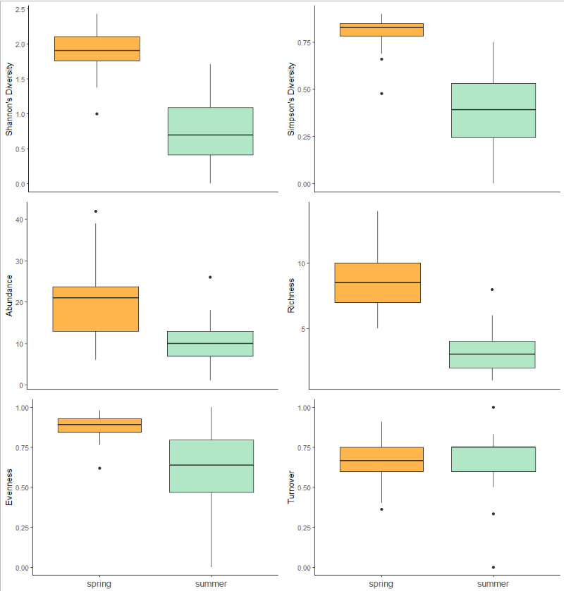

MERGE With Fig 3 or cutFigure 1: Spring levels of Shannon's Diversity Index, Simpson's Diversity Index, abundance, richness, and evenness for the avian community at Mojave National Preserve. GOOD but why not facet census instead and use color or fill to show microhabitat - ie shrub,open, cacti

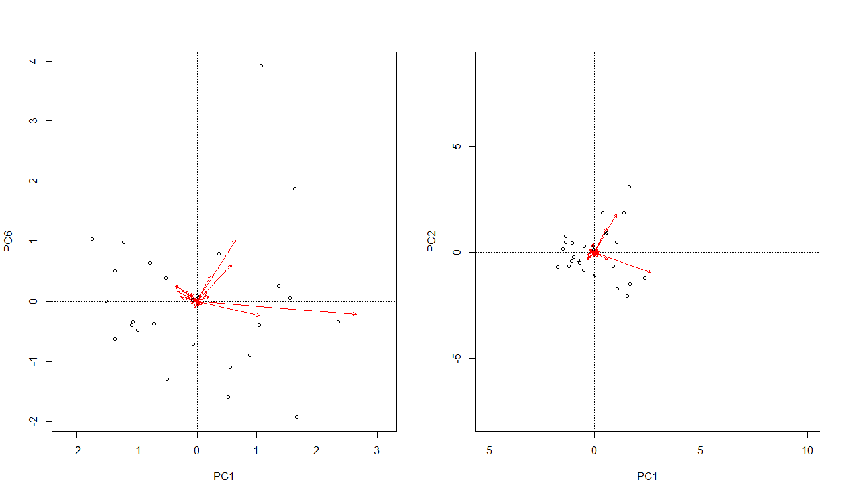

Figure 2: explain figure not stats here.

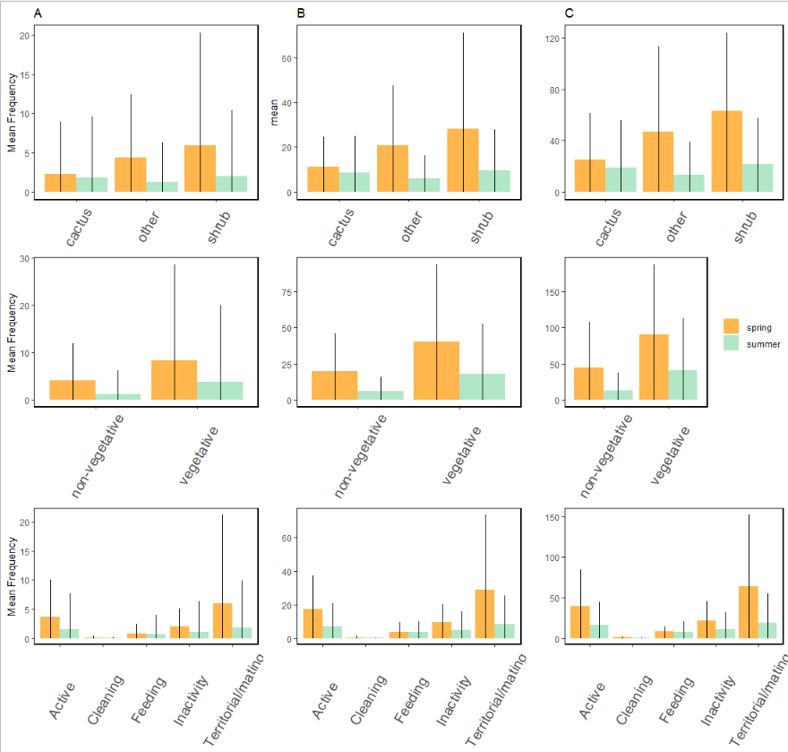

Figure 3: Mesohabitats, regardless of season and number of mesohabitat levels showed no significant differences in bird association. However, analyses on bird behaviors showed territorial/mating behaviors were significantly higher than cleaning behaviors. Between A) species abundance, B) trophic guild abundance, and C) migration class abundance analyses, behavior was consistently the only model that showed significant differences.

Cut veg and non-veg

Flip facet and fill by census and micro./

This plot is also redundant to fig 1.

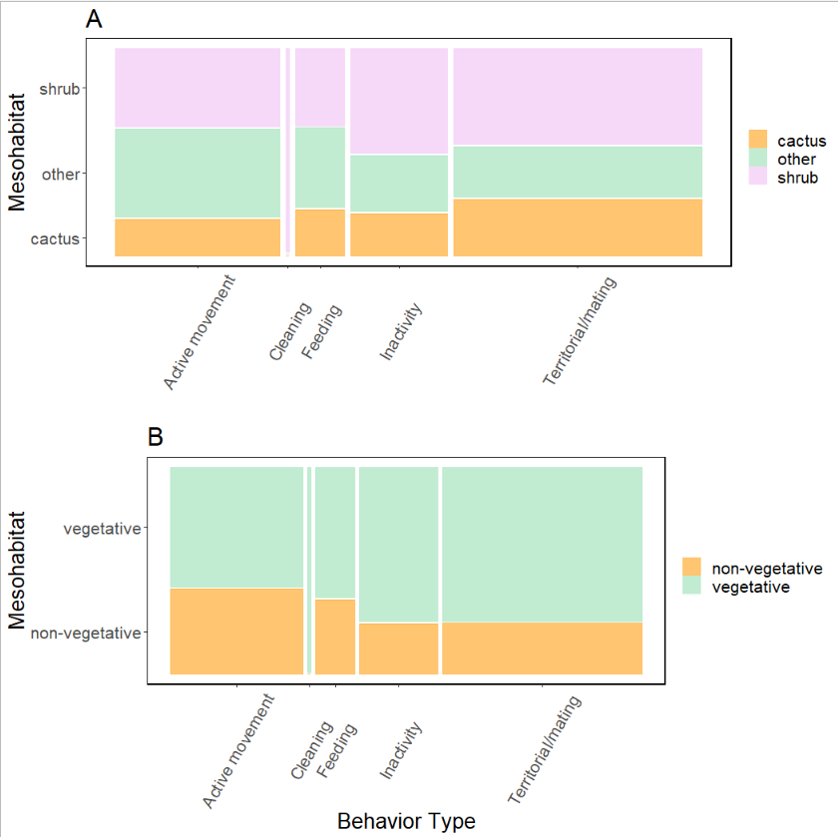

Figure 4: The mesohabitat a bird associated with had significant impact on the behavior that bird was exhibiting. When delineating mesohabitat into A) three levels, we found that mesohabitats that were not shrub or cacti positively influenced active movement but negatively influenced territorial/mating behaviors. This information was recontextualized when mesohabitat was broaden into B) two levels, where we then found vegetative mesohabitats had a negative influence on active movement and a positive influence on territorial/mating behaviors and for non-vegetative mesohabitats, the opposite was true: non-vegetative mesohabitat positively influenced active movement but restricted territorial/mating behaviors.

Like fig a - NICE!

References:

Almeida, Adriana de, and Sandra Bos Mikich. 2018. “Combining plant–frugivore networks for describing the structure of neotropical communities.” *Oikos* 127 (2): 184–97. <https://doi.org/10.1111/oik.04774>.

Angelini, Christine, Andrew H. Altieri, Brian R. Silliman, and Mark D. Bertness. 2011. “Interactions among Foundation Species and Their Consequences for Community Organization, Biodiversity, and Conservation.” *BioScience* 61 (10): 782–89. <https://doi.org/10.1525/bio.2011.61.10.8>.

Arsenault, Randal, and Norman Owen-Smith. 2002. “Facilitation versus competition in grazing herbivore assemblages.” *Oikos* 97 (3): 313–18. <https://doi.org/10.1034/j.1600-0706.2002.970301.x>.

Barker, Jessica L., Judith L. Bronstein, Maren L. Friesen, Emily I. Jones, H. Kern Reeve, Andrew G. Zink, and Megan E. Frederickson. 2017. “Synthesizing perspectives on the evolution of cooperation within and between species.” *Evolution* 71 (4): 814–25. <https://doi.org/10.1111/evo.13174>.

Bertness, Mark D., George H. Leonard, Jonathan M. Levine, Paul R. Schmidt, and Aubrey O. Ingraham. 1999. “Testing the relative contribution of positive and negative interactions in rocky intertidal communities.” *Ecology* 80 (8): 2711–26. [https://doi.org/10.1890/0012-9658(1999)080[2711:TTRCOP]2.0.CO;2](https://doi.org/10.1890/0012-9658(1999)080%255B2711:TTRCOP%255D2.0.CO%3B2).

Bonanomi, Giuliano, Guido Incerti, and Stefano Mazzoleni. 2011. “Assessing occurrence, specificity, and mechanisms of plant facilitation in terrestrial ecosystems.” *Plant Ecology* 212 (11): 1777–90. <https://doi.org/10.1007/s11258-011-9948-5>.

Boyles, Justin G., Nigel C. Bennett, Osama B. Mohammed, and Abdulaziz N. Alagaili. 2017. “Torpor patterns in desert hedgehogs (Paraechinus aethiopicus) represent another new point along a thermoregulatory continuum.” *Physiological and Biochemical Zoology* 90 (4): 445–52. <https://doi.org/10.1086/691542>.

Bronstein, Judith L. 2001. “The costs of mutualism.” *American Zoologist* 41 (4): 825–39. <https://doi.org/10.1093/icb/41.4.825>.

———. 2009. “The evolution of facilitation and mutualism.” *Journal of Ecology* 97 (6): 1160–70. <https://doi.org/10.1111/j.1365-2745.2009.01566.x>.

Buler, Jeffrey J., Frank R. Moore, and Stefan Woltmann. 2007. “A multi-scale examination of stopover habitat use by birds.” *Ecology* 88 (7): 1789–1802. <https://doi.org/10.1890/06-1871.1>.

Callaway, Ragan M. 200AD. *Positive Interactions and Interdependence in Plant Communities*. First. Dordrecht: Springer.

———. 1997. “Positive interactions in plant communities and the individualistic-continuum concept.” *Oecologia* 112 (2): 143–49. <https://doi.org/10.1007/s004420050293>.

Cardinale, Bradley J., Margaret A. Palmer, and Scott L. Collins. 2002. “Species diversity enhances ecosystem functioning through interspecific facilitation.” *Nature* 415 (6870): 426–29. <https://doi.org/10.1038/415426a>.

Choler, Philippe, Richard Michalet, and Ragan M. Callaway. 2001. “Facilitation and competition on gradients in alpine plant communities.” *Ecology* 82 (12): 3295–3308. [https://doi.org/10.1890/0012-9658(2001)082[3295:FACOGI]2.0.CO;2](https://doi.org/10.1890/0012-9658(2001)082%255B3295:FACOGI%255D2.0.CO%3B2).

De Graaf, Richard M, Nancy G. Tilghman, and Stanley H. Anderson. 1985. “Foraging Guilds of North American Birds.” *Environmental Management* 9 (6): 493–536.

Fahse, L., W. R. J. Dean, and C. Wissel. 1998. “Modelling the size and distribution of protected areas for nomadic birds: Alaudidae in the Nama-Karoo, South Africa.” *Biological Conservation* 85 (1-2): 105–12. <https://doi.org/10.1016/S0006-3207(97)00137-7>.

Filazzola, Alessandro, and Christopher J. Lortie. 2014. “A systematic review and conceptual framework for the mechanistic pathways of nurse plants.” *Global Ecology and Biogeography* 23 (12): 1335–45. <https://doi.org/10.1111/geb.12202>.

Filazzola, Alessandro, Michael Westphal, Michael Powers, Amanda Rae Liczner, Deborah A. Smith Woollett, Brent Johnson, and Christopher J. Lortie. 2017. “Non-trophic interactions in deserts: Facilitation, interference, and an endangered lizard species.” *Basic and Applied Ecology* 20: 51–61. <https://doi.org/10.1016/j.baae.2017.01.002>.

FINK, ALIX D., FRANK R. THOMPSON, and APRIL A. TUDOR. 2006. “Songbird Use of Regenerating Forest, Glade, and Edge Habitat Types.” *Journal of Wildlife Management* 70 (1): 180–88. [https://doi.org/10.2193/0022-541x(2006)70[180:suorfg]2.0.co;2](https://doi.org/10.2193/0022-541x(2006)70%255B180:suorfg%255D2.0.co%3B2).

Flores-Torres, Arnoldo, and Andrea Galindo-Escamilla. 2017. “Pollination biology of Agave horrida (Agavaceae) in the Chichinautzin mountain range, Central Mexico.” *Botanical Sciences* 95 (3): 423–31. <https://doi.org/10.17129/botsci.1022>.

Franco, A C, and P S Nobel. 1989. “Effect of Nurse Plants on the Microhabitat and Growth of Cacti.” *Journal of Ecology* 77 (3): 870–86.

Geiser, Fritz, and Thomas Ruf. 1995. “Hibernation versus Daily Torpor in Mammals and Birds: Physiological Variables and Classification of Torpor Patterns.” *Physiological Zoology* 68 (6): 935–66.

Gelmi-Candusso, Tiziana A., Eckhard W. Heymann, and Katrin Heer. 2017. “Effects of zoochory on the spatial genetic structure of plant populations.” *Molecular Ecology* 26 (21): 5896–5910. <https://doi.org/10.1111/mec.14351>.

Gómez-Aparicio, Lorena, Regino Zamora, Jorge Castro, and Jose A. Hódar. 2008. “Facilitation of tree saplings by nurse plants: Microhabitat amelioration or protection against herbivores?” *Journal of Vegetation Science* 19 (2): 161–72. <https://doi.org/10.3170/2008-8-18347>.

Graff, Pamela, and Martín R. Aguiar. 2011. “Testing the role of biotic stress in the stress gradient hypothesis. Processes and patterns in arid rangelands.” *Oikos* 120 (7): 1023–30. <https://doi.org/10.1111/j.1600-0706.2010.19059.x>.

Gurin, Catherine, Tasha La Doux, and Sharon Coe. 2012. *Checklist for Birds of the Granite Mountains*. First. Natural Reserve System University for California.

Gutzwiller, Kevin J., and Wylie C. Barrow. 2003. “Influences of roads and development on bird communities in protected Chihuahuan Desert landscapes.” *Biological Conservation* 113 (2): 225–37. <https://doi.org/10.1016/S0006-3207(02)00361-0>.

Hernandez, R. R., S. B. Easter, M. L. Murphy-Mariscal, F. T. Maestre, M. Tavassoli, E. B. Allen, C. W. Barrows, et al. 2014. “Environmental impacts of utility-scale solar energy.” *Renewable and Sustainable Energy Reviews* 29: 766–79. <https://doi.org/10.1016/j.rser.2013.08.041>.

Lima, Steven L. 2009. “Predators and the breeding bird: Behavioral and reproductive flexibility under the risk of predation.” *Biological Reviews* 84 (3): 485–513. <https://doi.org/10.1111/j.1469-185X.2009.00085.x>.

Lortie, Christopher J., and Ragan M. Callaway. 2006. “Re-analysis of meta-analysis: Support for the stress-gradient hypothesis.” *Journal of Ecology* 94 (1): 7–16. <https://doi.org/10.1111/j.1365-2745.2005.01066.x>.

Lovich, Jeffrey E., and David Bainbridge. 1999. “Anthropogenic degradation of the southern California desert ecosystem and prospects for natural recovery and restoration.” *Environmental Management* 24 (3): 309–26. <https://doi.org/10.1007/s002679900235>.

Maestre, Fernando T., Fernando Valladares, and James F. Reynolds. 2005. “Is the change of plant-plant interactions with abiotic stress predictable? A meta-analysis of field results in arid environments.” *Journal of Ecology* 93 (4): 748–57. <https://doi.org/10.1111/j.1365-2745.2005.01017.x>.

Miranda-Jácome, Antonio, Carlos Montaña, and Juan Fornoni. 2013. “Sun/shade conditions affect recruitment and local adaptation of a columnar cactus in dry forests.” *Annals of Botany* 111 (2): 293–303. <https://doi.org/10.1093/aob/mcs255>.

Mitchell, Randall J., Rebecca J. Flanagan, Beverly J. Brown, Nickolas M. Waser, and Jeffrey D. Karron. 2009. “New frontiers in competition for pollination.” *Annals of Botany* 103 (9): 1403–13. <https://doi.org/10.1093/aob/mcp062>.

Nielsen, Uffe N., and Becky A. Ball. 2015. “Impacts of altered precipitation regimes on soil communities and biogeochemistry in arid and semi-arid ecosystems.” *Global Change Biology* 21 (4): 1407–21. <https://doi.org/10.1111/gcb.12789>.

Nobel, Park S. 1980. “Morphology , Nurse Plants , and Minimum Apical Temperatures for Young Carnegiea gigantea.” *Botanical Gazette* 141 (2): 188–91.

Oksanen, Jari F., Guillaume Blanchet, Michael Friendly, Roeland Kindt, Pierre Legendre, Dan McGlinn, Peter R. Minchin, et al. 2019. “Vegan: Community Ecology Package.” <https://cran.r-project.org/package=vegan>.

Parker, Kathleen C. 1989. “Nurse plant retationships of columnar cacti in arizona.” *Physical Geography* 10 (4): 322–35. <https://doi.org/10.1080/02723646.1989.10642386>.

Pfahl, S., P. A. O’Gorman, and E. M. Fischer. 2017. “Understanding the regional pattern of projected future changes in extreme precipitation.” *Nature Climate Change* 7 (6): 423–27. <https://doi.org/10.1038/nclimate3287>.

R Core Team. 2017. “R: A language and environment for statistical computing.” Vienna, Austria. <https://www.r-project.org/>.

Rodríguez-Estrella, Ricardo. 2007. “Land use changes affect distributional patterns of desert birds in the Baja California peninsula, Mexico.” *Diversity and Distributions* 13 (6): 877–89. <https://doi.org/10.1111/j.1472-4642.2007.00387.x>.

Runge, Claire, and Ayesha I. T. Tulloch. 2017. “Solving problems of conservation inadequacy for nomadic birds.” *Australian Zoologist* 39 (2): 280–95. <https://doi.org/10.7882/AZ.2016.003>.

Schwartz, Mark D. 2003. *Phenology: An integrative environmental science*. Second. New York: Springer Science+Business Media. <https://doi.org/10.1007/978-94-007-6925-0>.

Scott Sillett, T., and Richard T. Holmes. 2002. “Variation in survivorship of a migratory songbird throughout its annual cycle.” *Journal of Animal Ecology* 71 (2): 296–308. <https://doi.org/10.1046/j.1365-2656.2002.00599.x>.

Singh, Deepti, Michael Tsiang, Bala Rajaratnam, and Noah S. Diffenbaugh. 2013. “Precipitation extremes over the continental United States in a transient, high-resolution, ensemble climate model experiment.” *Journal of Geophysical Research Atmospheres* 118 (13): 7063–86. <https://doi.org/10.1002/jgrd.50543>.

Smith, Melinda D. 2011. “The ecological role of climate extremes: Current understanding and future prospects.” *Journal of Ecology* 99 (3): 651–55. <https://doi.org/10.1111/j.1365-2745.2011.01833.x>.

Tewksbury, Joshua J., and John D. Lloyd. 2001. “Positive interactions under nurse-plants: Spatial scale, stress gradients and benefactor size.” *Oecologia* 127 (3): 425–34. <https://doi.org/10.1007/s004420000614>.

Tonkin, Jonathan D., Michael T. Bogan, Núria Bonada, Blanca Rios-Touma, and David A. Lytle. 2017. “Seasonality and predictability shape temporal species diversity.” *Ecology* 98 (5): 1201–16. <https://doi.org/10.1002/ecy.1761>.